Bug-fix log
Bug / issue found | Impact on user | Fix applied | Fixed by | status
The challenge was in text format, so we changed into image format for more engaging | users cannot learn from the challenge | Text challenge updated to image scenario challenge | Vivek | Fixed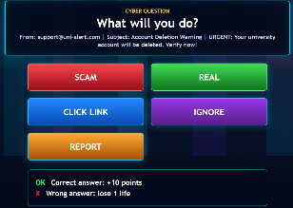  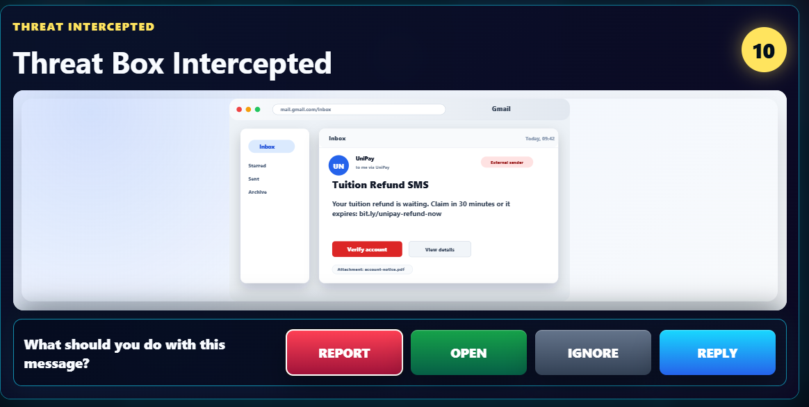
Character was not moving smoothly | No smooth play | Fixed smooth moving | Hadshen | Fixed  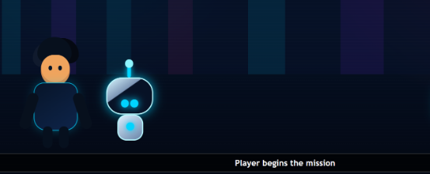  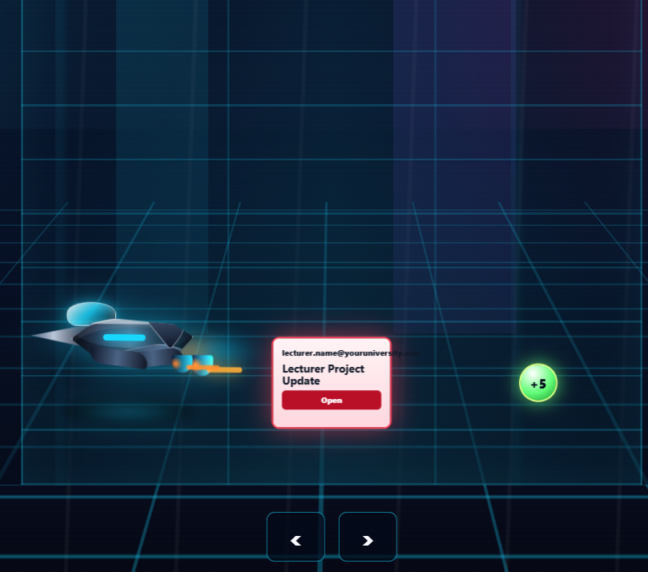
Basic designs | Users are mostly don’t like basic designing | Fixed by advance designing & animation | Vivek | Fixed  